Game Design Document

Fill up the following document

1. Write the title of your project.

Winning champ

1. What is the goal of the game?

We have to run and clear all obstacles and we have to win

1. Write a brief story of your game.

In this game four children will running clearing all obstacles as their aim is to win the race and win gold medal and make india proud.

1. Which are the playing characters of this game?

* Playing characters are the ones who respond to the user based on the input from the user.
* Cars, monkeys, dinos, wizards, etc., are the playing characters in the game.

|  |  |  |
| --- | --- | --- |
| Number | Character Name | What can this character do? |
| 1 |  | Run,jump |
| 2 |  | Run,jump |
| 3 |  | Run,jump |
| 4 |  | Run,jump |
| 5 |  |  |
| 6 |  |  |
| 7 |  |  |
| 8 |  |  |

1. Which are the Non-Playing Characters of this game?

* Non-Playing characters are the ones that don't have an action or behavior when the user interacts with the game.
* Hurdles, stones, bananas, coins, etc., are non-playing characters in the game.

|  |  |  |
| --- | --- | --- |
| Number | Character Name | What can this character do? |
| 1 | hurdles | slower the speed of a runner |
| 2 |  |  |
| 3 |  |  |
| 4 |  |  |
| 5 |  |  |
| 6 |  |  |
| 7 |  |  |
| 8 |  |  |

Draw your imagination of this game. What does this game look like?

* Draw the game either on your computer or on paper.
* Add images of the game scenes to show each of the playing and non-playing characters at least once.

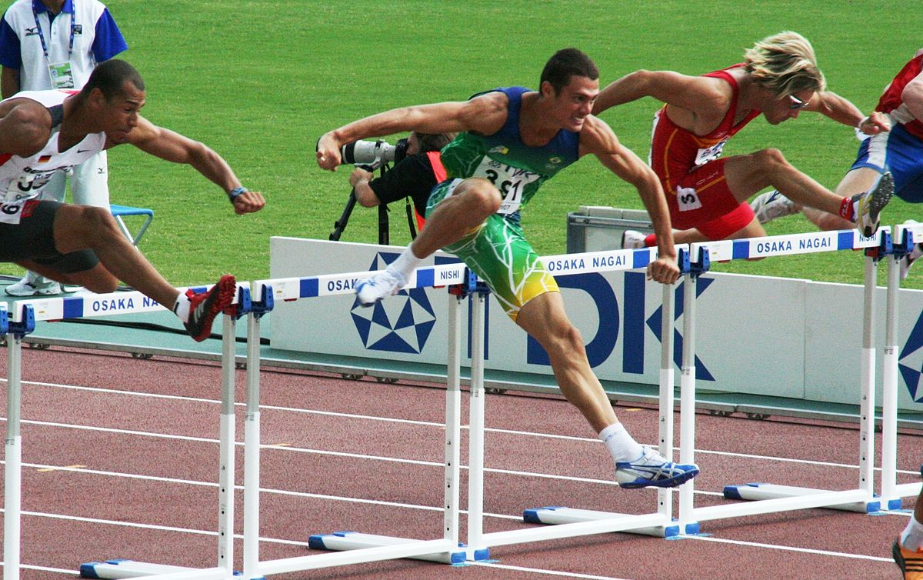

How do you plan to make your game engaging?

I will make the runner’s task more difficult